# MIPS Documentation and Style Guide

# CS/SE 3340 Computer Architecture

# Dr. Karen Mazidi

What makes good code good:

* Code logic should be easy to read
* Code should be modular
* Code style should be internally consistent
* Code should be documented internally and externally
* Code should be tested and verifiable
* Code should be efficient
* When you write code, think of the person who will have to maintain it.

Code Style.

What we call *style* generally involves things like use of white space, comments, naming identifiers, etc. A “Hello World” program is on the next page. Notice the following features.

* The file name HelloWorld.asm indicates the purpose of the program and ends in .asm
* A header comment block gives program information such as author, date, purpose
* Comments at the bottom of the main function show a sample run, or test case
* In-line comments are lined up vertically (not always possible)
* There is whitespace between the two main sections of code: .data and .text
* Label names for variables and code points are in their own vertical space on the left, all lower case; identifier names should be consistent in either camelCase or underscore_case
* Code is double indented: opcode and operand
* Each action of the code has its own comment to the side and is separated from other actions by a blank line

If I want to figure out what this code does a year from now, I can just scan the header comment block and the inline comments down the right and finally look at the sample run comments and I’ve got it. I can always drill down to the details as needed.

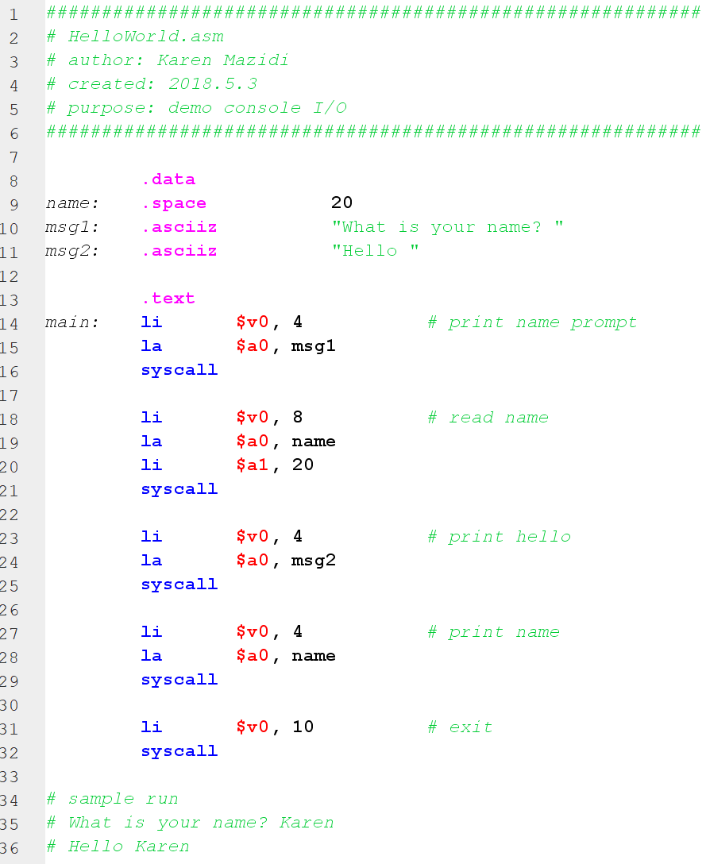

External Documentation.

Internal documentation as discussed above is useful for other programmers to read and understand your code. For a large project, however, we need external documentation a swell which includes things such as flow charts, UML diagrams, requirements documents, a user manual, legal info and more, depending on the environment. There are specialized external documentation programs like Sphinx (Python, C, C++), Doxygen (C++, PHP, Java, Python), and many more. You should learn at least one of those for your projects in other languages.

For our purposes in assembly language, we can keep things pretty simple. A Word document can be used to create a doc or pdf. Another option is to use markdown. Next, we show a simple example of external documentation in Markdown for the HelloWorld program, but first: What is Markdown? Markdown is a simple markup language that lets you format as you type without taking your keys off they keyboard. It is usually a plain text file ending in .md that can be rendered into html.

**Markdown Using Atom.**

There are a lot of free editors for Markdown but I’m going to discuss Atom since it is a common code editor, it is cross platform, and free. You can download atom here: <https://atom.io/>

Installation should be painless. Open Atom and start typing, save your document as .md

When you want to preview what the markdown will look like: ctrl-shift-m

To export the html, right-click on the markdown preview and choose save as html

If you want to change the default style to the GitHub style, Go to Packages -> Markdown -> toggle GitHub style

**Markdown Basics.**

Markdown cheat sheet: <https://guides.github.com/pdfs/markdown-cheatsheet-online.pdf>

What kinds of things can you do in markdown?

* Format headings
* Format text italic or bold
* Make lists (ordered or unordered)
* Place images
* Create links
* Show code blocks
* Tables

**Markdown Example.**

Below, we have a screen shot from within Atom showing our markdown code on the left and the rendered markdown on the right. Notice the following:

* Headers of varying sizes starting with #
* Bold text is surrounded by ** two stars**
* Italic text is surrounded by *one star*
* We can make ordered lists with * and indents
* We can insert a code block by starting and ending with 3 consecutive backticks, the first 3 backticks are followed by the code type, in our case we say assembly

